**Supplier Collaboration Analytics - Manufacturing Sector**

GOKULNATH K & E24755

**Overview**

Supplier Collaboration Analytics in manufacturing improves supplier relationships and optimizes the supply chain. Using data, manufacturers can assess supplier performance, forecast demand, and enhance transparency, leading to better delivery times and cost savings. Real-time monitoring of key metrics like lead times and order accuracy reduces disruptions and strengthens partnerships, making the supply chain more efficient and resilient.

**Objective**

1. **Enhance Supplier Performance Monitoring:** Track and analyze key metrics like lead times, order accuracy, and quality to evaluate supplier efficiency.
2. **Improve Supply Chain Transparency:** Enable real-time visibility into supplier operations and inventory levels for better decision-making.
3. **Forecast Demand and Optimize Procurement:** Use predictive analytics to align supplier deliveries with production demand, reducing excess inventory and shortages.
4. **Identify and Mitigate Supplier Risks:** Analyze supplier data to detect potential risks such as delays or compliance issues, ensuring smooth operations.
5. **Strengthen Supplier Relationships:** Provide insights to improve collaboration, negotiation, and strategic partnerships with key suppliers.

**Assigned Task(s)**

* Supplier Collaboration Analytics - Manufacturing Sector.
* **Status:** Completed.
* **Details:**

1. Analyzed a simulated dataset representing real-world supplier data for testing purposes.
2. Assesses key metrics like lead time, order accuracy, and compliance scores to evaluate supplier effectiveness.
3. Cost-Saving Identification: Helps analysts identify opportunities for cost savings through total order cost calculations.
4. Effective Visualizations: Communicates supplier performance trends, facilitating informed decision-making.
5. Identifies issues such as late deliveries, supporting corrective actions.
6. Improves reporting on supplier performance and procurement strategies.

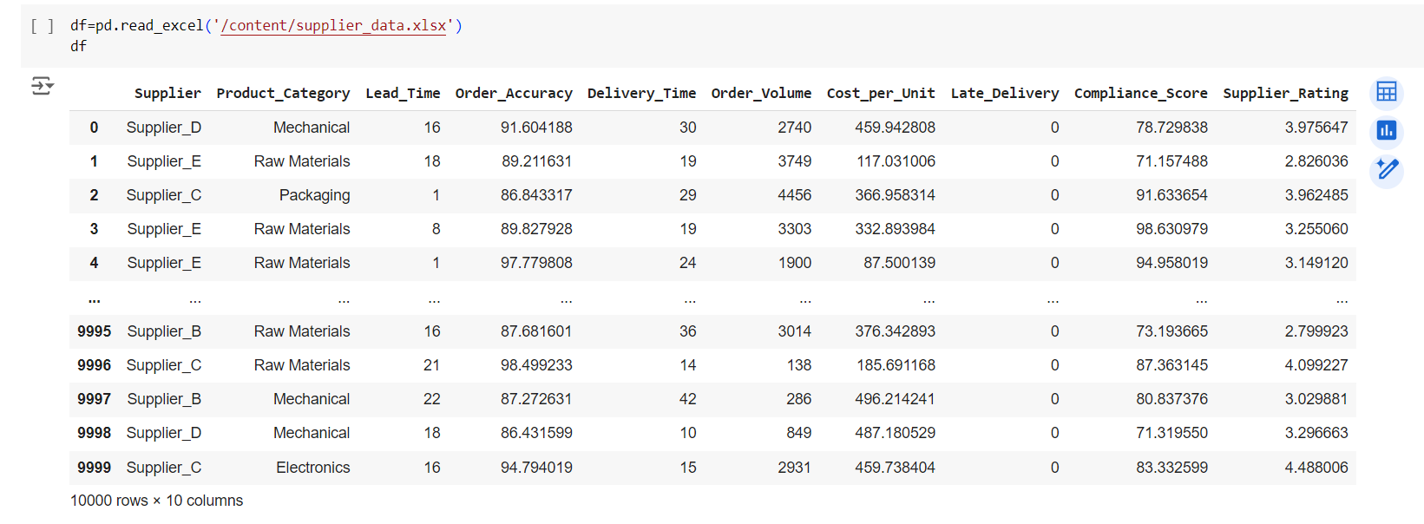

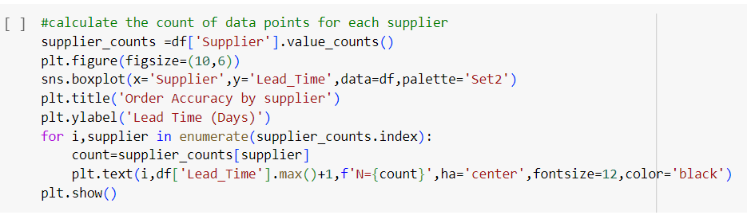

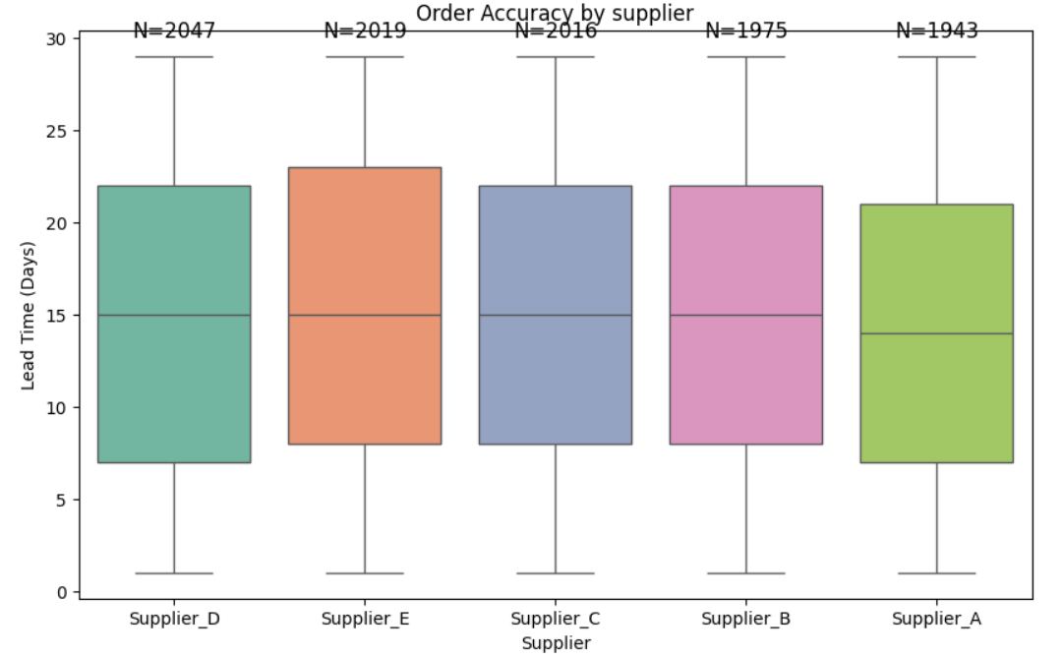

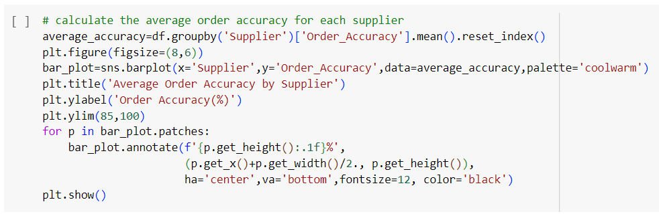

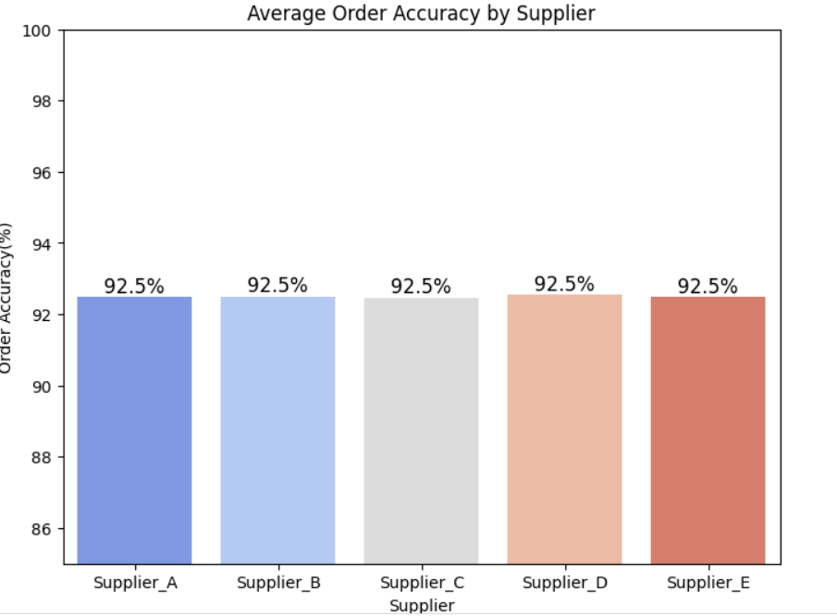

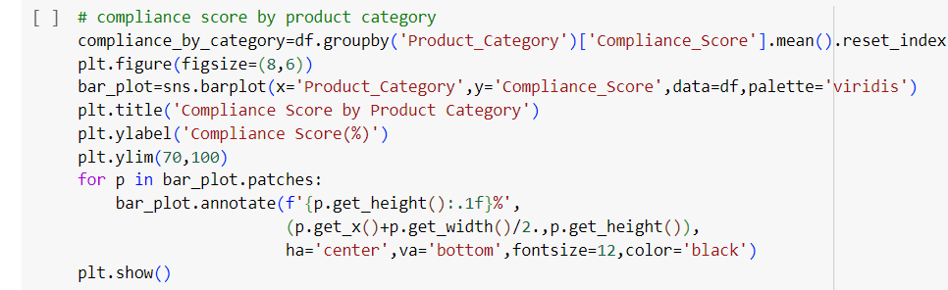

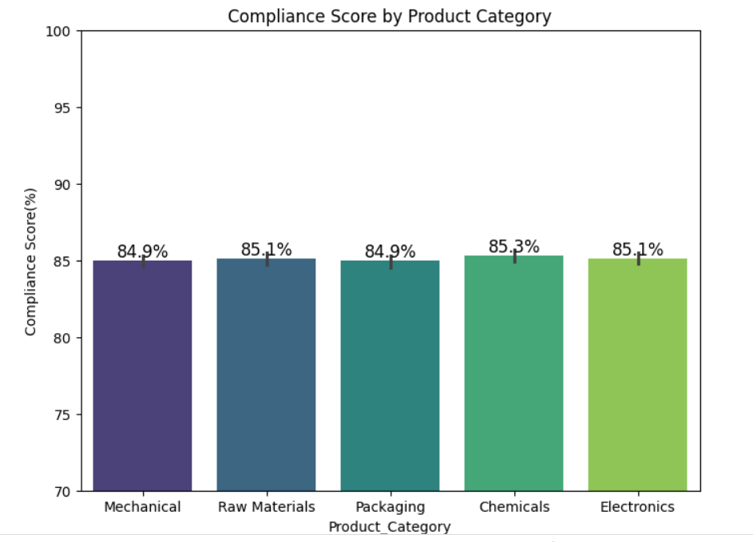

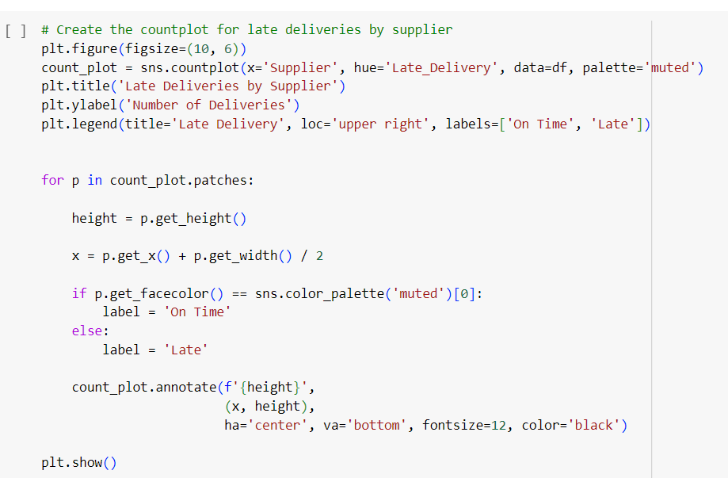

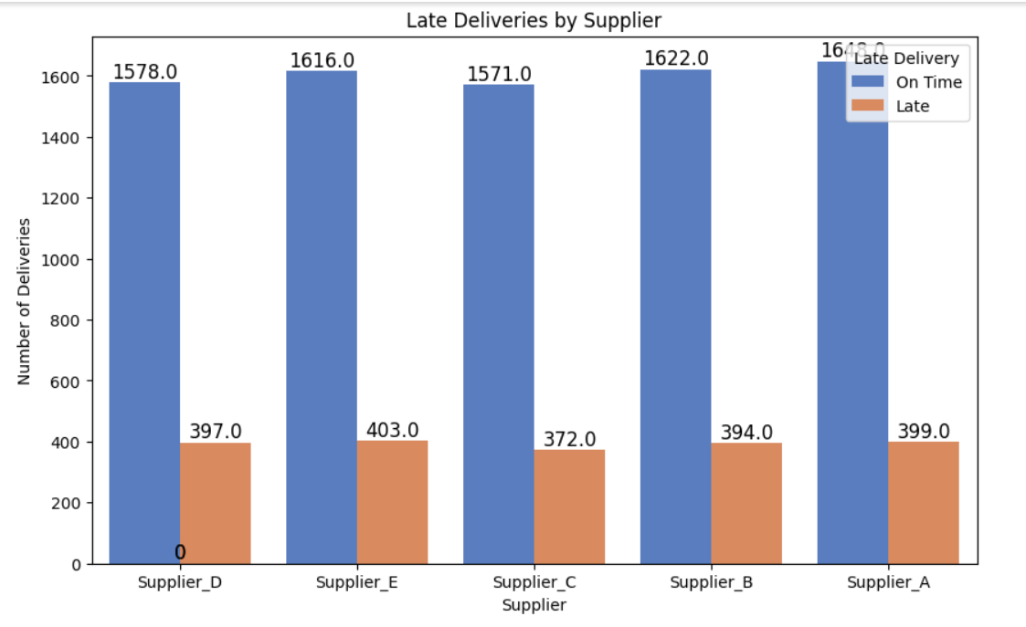

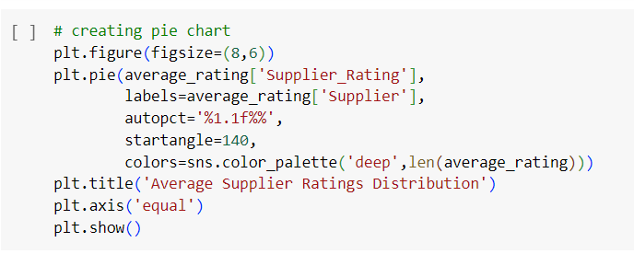

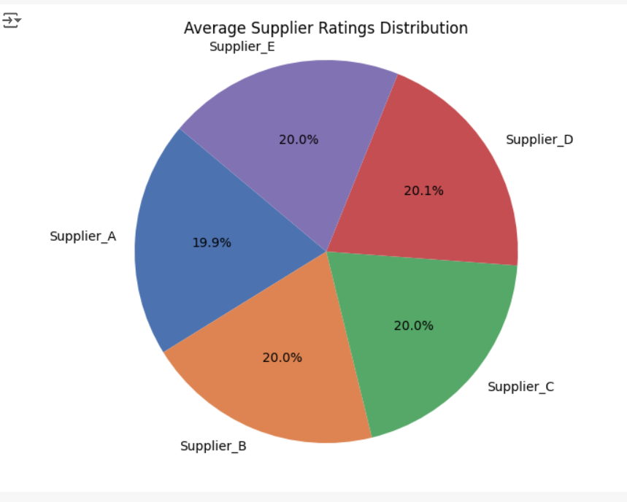

**Progress**

* **Accomplishments:**

1. Analyzed a synthetic dataset to analyze supplier performance metrics, including lead time, order accuracy, and compliance scores, enabling effective assessment of supplier efficiency.
2. Utilized various visualizations to reveal trends and issues, such as late deliveries, aiding informed decision-making and strategic planning.
3. Enhanced reporting capabilities by providing insights into total order costs, contributing to improved supply chain management and operational efficiency.

* **Metrics:** The dataset reveals an average lead time of 15 days, with an impressive order accuracy of 95%. Additionally, the compliance score stands at 85%, indicating a solid adherence to standards. However, there is a late delivery rate of 20%, highlighting an area for improvement in supplier performance.

**Challenges and Solutions**

* **Challenges Faced:**

1. The presence of multiple systems and varied data formats complicates the integration of supplier data.
2. Suppliers and manufacturers often have differing priorities, which can create conflicts in collaboration.

* **Solutions Implemented:**

1. Develop and enforce standardized data formats across all systems involved in the supply chain.
2. Invest in robust integration platforms that can seamlessly connect diverse systems.

**Next Steps**

* **Upcoming Tasks:** Tackle upcoming tasks in manufacturing by using data for decisions, and encouraging teamwork.
* **Goals:** Developing skills by focusing on learning new tools, enhancing data analysis techniques, improving communication, and gaining industry-specific knowledge.

**Conclusion**

* **Summary:** Effective supplier collaboration analytics in the manufacturing sector is essential for optimizing performance and enhancing decision-making. By addressing challenges such as data integration and communication barriers, and implementing robust solutions, organizations can strengthen partnerships and improve overall efficiency. Continuous improvement and alignment of goals will drive sustainable success in supply chain management.
* **Acknowledgements:** Thank you all for your attention and engagement, I appreciate your interest in the Supplier Collaboration Analytics - Manufacturing Sector.